**Machine Learning-Based Prediction of Aerodynamic Coefficients for Wing Design Optimization**

**ABSTRACT**

This research focuses on using machine learning (ML) models to predict the aerodynamic performance of the wings. Traditional methods like Computational Fluid Dynamics (CFD) are accurate but very slow and need a lot of computing power. In this study, we used tools like OpenVSP and VSPAero to create a dataset of wing designs with different shapes and measured their aerodynamic properties like lift (Cl), drag (Cd), and moment (Cm). We then trained different ML models—such as ANN, CNN, MLP, DNN, SVR, PINN, and Random Forest—to predict these values. After testing and comparing them, we found that MLP and CNN gave the best results. These models can help reduce the time and cost of designing better airfoils and wings by avoiding repeated CFD simulations.

**1.INTRODUCTION**

**1.1** **Background and Motivation**Computational Fluid Dynamics (CFD) is now a cornerstone in aerodynamic design, enabling detailed analysis of lift, drag, pressure distribution, and flow separation. It supports performance evaluation across various airfoil geometries and flight conditions[1] [2].

Despite its accuracy, CFD-based optimization is computationally expensive and time-intensive. Each simulation requires fine mesh generation, solver convergence, and high processing power, limiting the speed of design iteration[3] [4].

AI and Machine Learning offer a faster, scalable alternative to traditional CFD by learning aerodynamic behavior from existing simulation data. Models like neural networks and CNNs can accurately predict aerodynamic coefficients and even generate optimized shapes[5] [6].

**1.2 Literature Review**

|  |  |  |  |  |  |  |
| --- | --- | --- | --- | --- | --- | --- |
| SR.No | Paper Title | Author(s) | Objective | Method | Application | Key Findings (Outcome Parameters) |
| 1 | Generative AI Driven Aerodynamic Shape Optimization [5] | Shumail Sahibzada et al. | Improve aerodynamic shapes using AI | Neural networks + CFD + Generative AI | Aerodynamic design optimization | Drag reduction by 13.2%, Lift-to-Drag ratio (L/D) increase by 18.7%, Computational time reduced by 42% |
| 2 | A Comprehensive Review of Neural Network Training Approaches [7] | Apurva Anand et al. | Review of NN training for airfoils | Compared training strategies like SGD, BP | Improve NN model training | Accuracy increase by 10–15% using adaptive training methods |
| 3 | Application of CNN to Predict Airfoil Lift Coefficient [8] | Yao Zhang et al. | Predict lift coefficient using CNN | Convolutional Neural Network | Quick lift prediction | Accuracy achieved 92%, Computation time reduced by 60% |
| 4 | A Machine Learning-Based Approach for Predicting Aerodynamic Coefficients [9] | Mara-Florina Negoita et al. | Predict coefficients from CFD data | Deep Neural Network | Replacing full CFD simulations | Mean error < 5%, Prediction speed increased by 70% |
| 5 | Airfoil’s Aerodynamic Coefficients Prediction using ANN [10] | Hassan Moin et al. | Predict aero coefficients with ANN | Artificial Neural Network | Airfoil performance prediction | Error < 7%, Training speed improved significantly |
| 6 | Multiple Aerodynamic Coefficient Prediction [6] | Hai Chen et al. | Predict Cl, Cd, Cm together | CNN trained on airfoil data | Multi-output aerodynamic predictions | Accuracy of 95% for all outputs (Cl, Cd, Cm) |
| 7 | Machine Learning to Predict Aerodynamic Stall  [11] | Ettore Saetta et al. | Predict stall behavior | ML classifier trained on stall data | Stall prediction in aircraft | Accuracy between 85%–90% |
| 8 | Diffusion Transformers for RANS Simulations of Airfoil Flows [12] | Hui Xiang et al. | Improve RANS simulations with ML | Diffusion Transformers + Physics models | RANS flow simulation for airfoils | Velocity field error reduced by 20–30% |
| 9 | Fast Simulation of Airfoil Flow Field via DNN [2] | Kuijun Zuo et al. | Fast airfoil flow simulation | Deep neural network | Flow field prediction | Runtime reduced by 80%, Accuracy maintained at high levels |
| 10 | Airfoil Aerodynamic Performance Prediction Using ML and Surrogate Modeling [1] | Amir Teimourian et al. | Predict aero performance using ML & surrogate models | Combined ML with surrogate modeling | Faster CFD analysis | Error < 5%, Time savings increased by 60%+ |
| 11 | Enhancing Airfoil Performance through ANN & GA [13] | Mara-Florina Negoita et al. | Combine ANN + Genetic Algorithm | Optimization of airfoils | Enhanced aerodynamic performance | Lift-to-Drag ratio (L/D) improved by 15–20% |
| 12 | Aerodynamic Analysis and ANN-Based Optimization [4] | Sanan H. Khan et al. | Improve UAV airfoils with ANN | ANN + CFD data for training | UAV-specific airfoil optimization | Predicted performance with >90% accuracy |
| 13 | Advancing Airfoil Design: A Physics-Inspired NN Model [14] | Mathieu Salz et al. | Use physics-based NN model | Physics-informed Neural Network (PINN) | Realistic aero prediction | Error reduction by 25%, Generalization improvement |
| 14 | A Comparative Evaluation of Shape Parameterization for Airfoils [15] | Ananth Sridharan et al. | Compare shape parameterization methods | Evaluated NN performance with different shapes | Shape encoding for optimization | Best parameterization results in 10%+ performance improvement |
| 15 | Airfoil Optimization Using a ML-Based Optimization Algorithm [3] | Xueyi Song et al. | Optimize airfoils with ML | ML-based optimization algorithm | Design optimization | Lift increase by 12%, Drag reduction by 9% |

The literature review shows that using machine learning (ML) and neural networks (NN) has helped improve air foil designs, with studies reporting better accuracy (up to 95%) and faster computation times (up to 80% less)[8] [2].Different optimization methods, like ML algorithms and different models, have led to better lift, drag, and lift-to-drag ratios. But there are still gaps in models for multiple outputs, testing them in real-world conditions, and making them more efficient[3] [5] [13].

**1.3 Terminology**

A fundamental understanding of aerodynamic principles is essential for analyzing airfoil behaviour in computational studies. Key aerodynamic coefficients such as the lift coefficient (CL), drag coefficient (Cd​), and moment coefficient (Cm​) are used to quantify the aerodynamic forces acting on an air foil and are critical for performance evaluation. The flow characteristics around the air foil are strongly influenced by the boundary layer, which can separate from the surface under adverse pressure gradients, leading to increased drag and stall[16].

Aircraft performance further depends on a balance of forces—lift, drag, thrust, and weight—with the lift-to-drag ratio (L/D) serving as a key metric for aerodynamic efficiency. Stalling occurs when the angle of attack increases beyond a critical limit, causing flow separation and a sudden loss of lift. Additionally, geometric parameters such as camber (air foil curvature), angle of attack (AoA), and dihedral angle (wing tilt) play important roles in lift generation and stability[16].

Machine Learning (ML) helps make CFD simulations faster and easier[17].  
There are two main types of ML used in CFD: classification and regression.  
Classification is used when we want to sort things into categories—like whether airflow is laminar or turbulent, or if an air foil is in stall or not.  
For example, based on angle of attack and speed, ML can tell if an air foil will stall[18] [19].  
Regression is used to predict continuous values like lift or drag coefficients.  
This helps us know how much lift or drag an air foil will produce under certain conditions.  
Models like linear regression, decision trees, and neural networks are commonly used[18] [19]. These ML models are trained using CFD data and can give quick predictions.  
They save a lot of time compared to running full CFD simulations every time.[17]

**1.4 Comparison**

|  |  |  |  |
| --- | --- | --- | --- |
| S. No. | Research Paper | ML Method Used | Aerodynamic Parameters Considered |
| 1 | Generative AI Driven Aerodynamic Shape Optimization[5] | Generative Neural Network (GAN) | Air foil shape, Lift coefficient (CL), Drag coefficient (Cd) |
| 2 | A Comprehensive Review of Neural Network Training Approaches[7] | Artificial Neural Network (ANN) – Review | Various: CL, Cd, Angle of attack (AoA), Reynolds number |
| 3 | Application of Convolutional Neural Network to Predict Airfoil Lift Coefficient[8] | Convolutional Neural Network (CNN) | Air foil shape, AoA, CL |
| 4 | A Machine Learning-Based Approach for Predicting Aerodynamic Coefficients[9] | Deep Neural Network (DNN) | CL, Cd, AoA, Reynolds number |
| 5 | Airfoil’s Aerodynamic Coefficients Prediction using Artificial Neural Network[10] | Artificial Neural Network (ANN) | CL, Cd, Mach number, AoA |
| 6 | Multiple Aerodynamic Coefficient Prediction[6] | Convolutional Neural Network (CNN) | Air foil shape image, CL, Cd, Moment coefficient Cm |
| 7 | Machine Learning to Predict Aerodynamic Stall[11] | Binary Classification Model | Stall status, AoA, Flow velocity |
| 9 | Fast Simulation of Airfoil Flow Field via Deep Neural Network[2] | Deep Neural Network (DNN) | Flow field data, AoA, CL, Cd |
| 10 | Airfoil Aerodynamic Performance Prediction Using ML and Surrogate Modelling[1] | Surrogate Modelling + Machine Learning | CL ,Cd, C_M, Airfoil shape |
| 11 | Enhancing Airfoil Performance through Artificial Neural Networks and Genetic Algorithm[13] | Artificial Neural Network (ANN) + Genetic Algorithm (GA) | CL, Cd, Camber, AoA |
| 12 | Aerodynamic Analysis and ANN-Based Optimization of NACA Airfoils[9] | Artificial Neural Network (ANN) | NACA airfoil profile, CL, Cd, AoA |
| 13 | Advancing Airfoil Design: A Physics-Inspired Neural Network Model[14] | Physics-Informed Neural Network (PINN) | Flow physics, CL, Cd, Boundary layer behavior |
| 14 | A Comparative Evaluation of Shape Parameterization for Airfoil Optimization[15] | ANN + Parametric Modelling | Shape descriptors, CL, Cd, Cm |
| 15 | Airfoil Optimization Using a Machine Learning-Based Optimization Algorithm[3] | ML-Based Optimizer | CL, Cd, Design constraints |

**1.5 Challenges**

AI/ML-based CFD optimization faces several challenges that limit its widespread application. the lack of high-quality and diverse CFD datasets makes it difficult to train generalizable machine learning models effectively[8].Ensuring that ML predictions remain physically consistent with fluid dynamics laws such as mass or momentum conservation remains a major concern[20].Integration of ML models with traditional CFD solvers often encounters compatibility issues due to differences in programming environments and data structures[8].training deep learning models for CFD applications requires significant computational resources, which can reduce the overall efficiency gains[21].

This research plans to fill these gaps by creating a best model, testing it with real data, and improving its efficiency. This will help make ML a more practical tool for designing air foils and wings.

**2.METHODOLOGY**

**2.1 Dataset Preparation**The dataset was generated using OpenVSP, an open-source tool for parametric aircraft modelling. A wing was designed with adjustable parameters like camber, camber location, taper ratio, dihedral angle and angle of attack. Multiple configurations were created by systematically varying these inputs. Aerodynamic coefficients (Cl, Cd, Cm) were obtained using VSPAero’s built-in solver. To ensure accuracy, results were compared with ANSYS Fluent simulations, confirming the reliability of the OpenVSP outputs. This process resulted in a diverse and realistic dataset suitable for machine learning model training.

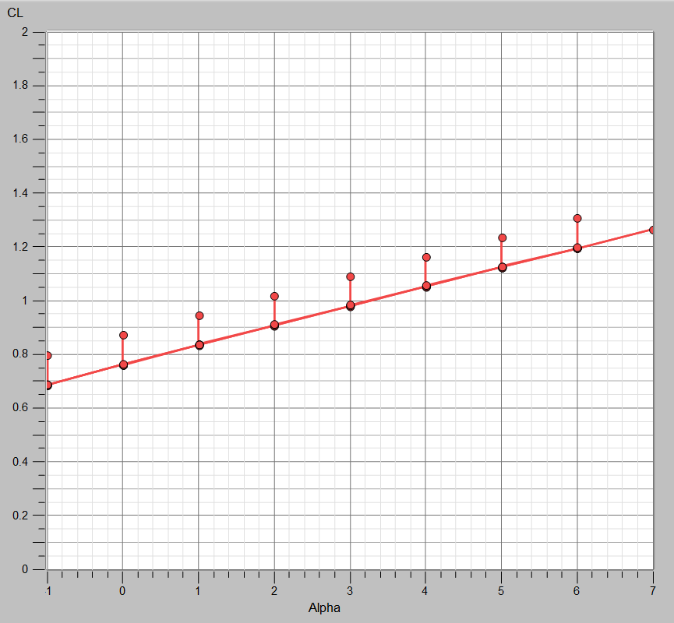 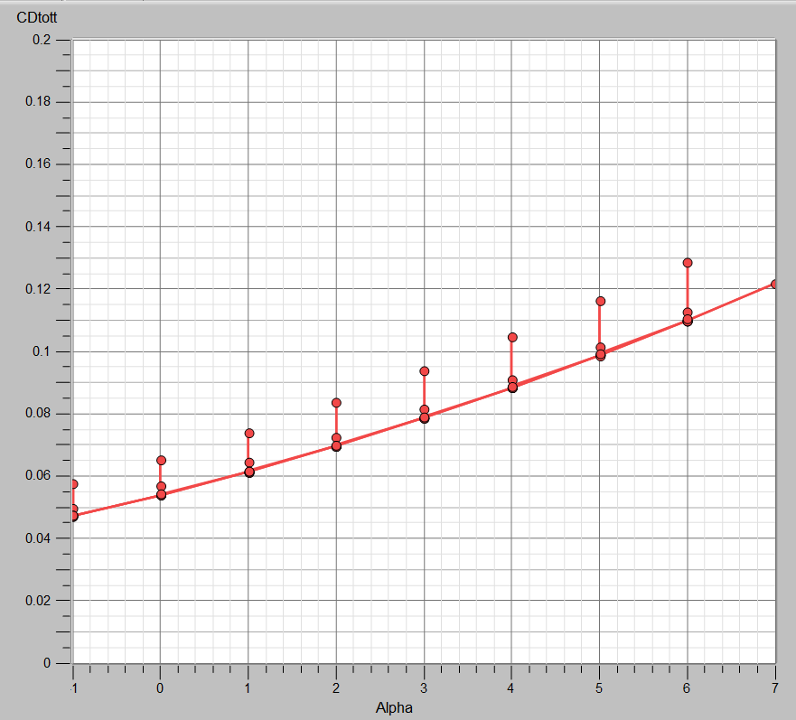

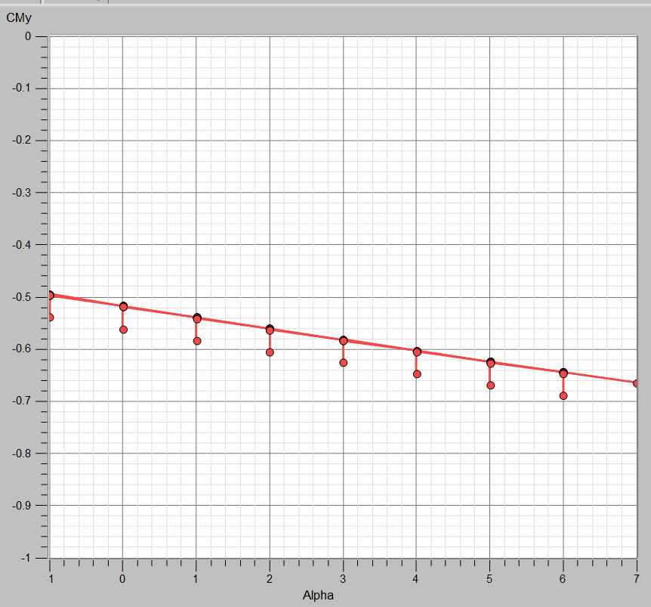 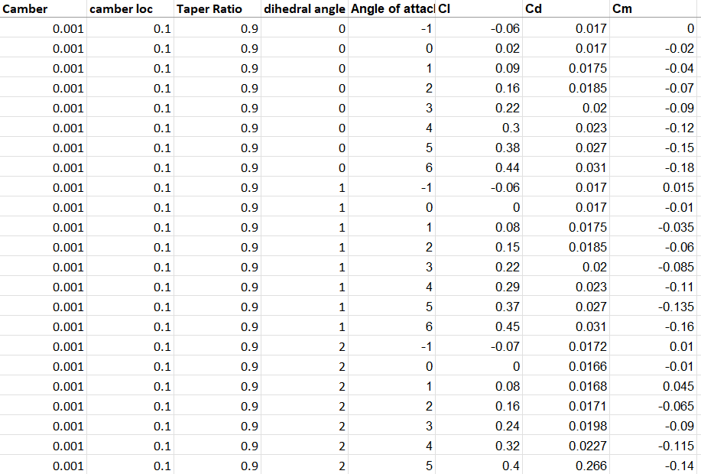  
**2.2 Model Preparation**

Multiple machine learning algorithms were implemented to model the relationship between airfoil geometry and aerodynamic performance. The following models were developed and trained:

**A.** Artificial Neural Network (ANN)

An Artificial Neural Network (ANN) is a computational model inspired by the way biological neural networks in the human brain work. It consists of layers of nodes, where each node is connected to others in adjacent layers. ANNs are used to identify patterns and make predictions. In the context of aerodynamics, they can be trained to predict aerodynamic coefficients (Cl, Cd, Cm) based on input parameters such as the shape of an airfoil or flow conditions[7] [10] [4].

* Structure: Input layer → Hidden layers → Output layer

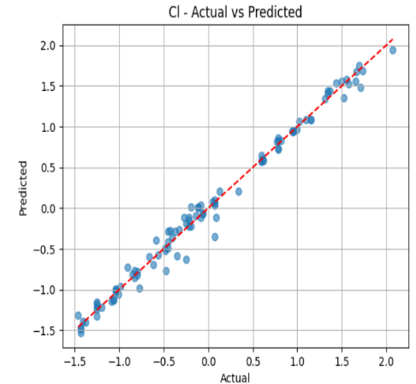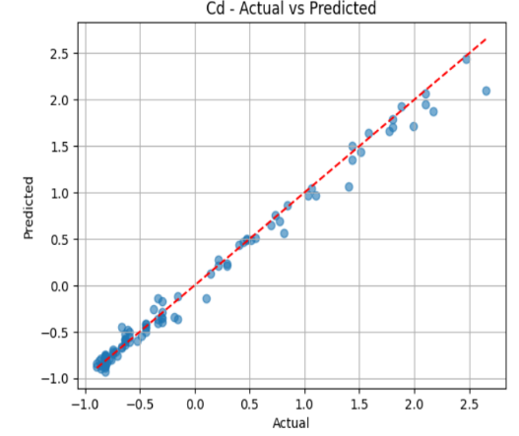 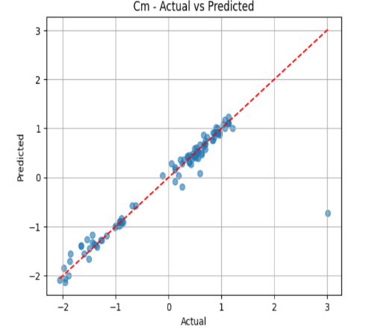

**B.** Convolutional Neural Network (CNN)

A Convolutional Neural Network (CNN) is a type of neural network primarily used for processing grid-like data, such as images. CNNs use convolutional layers to automatically extract features from input images, such as edges, corners, or textures, which are then used for classification or regression tasks. In aerodynamics, CNNs are often used to predict properties like the lift coefficient (Cl) from airfoil images or geometry [17] [6].

* Structure: Convolutional layers → Pooling layers → Fully connected layers

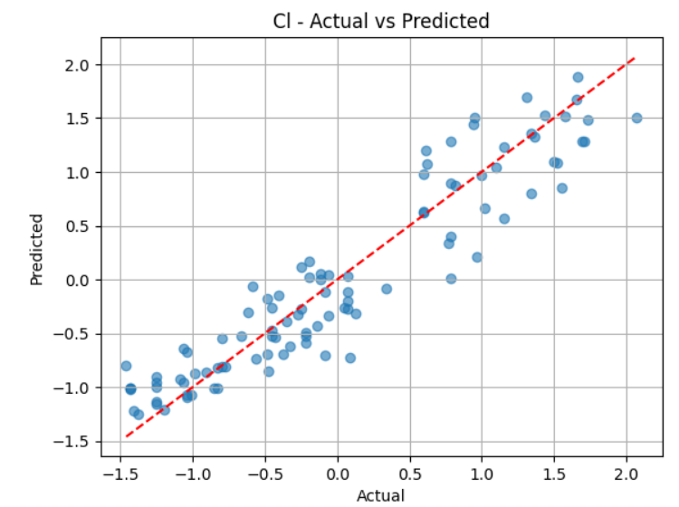 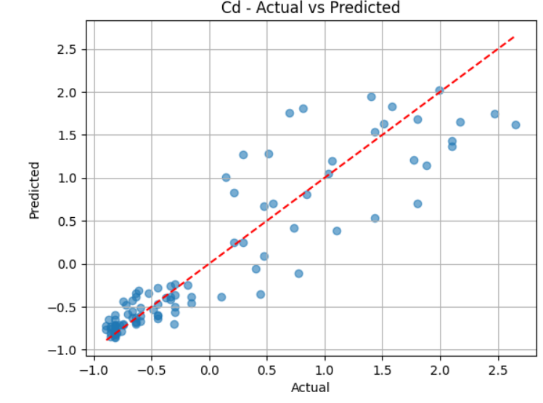 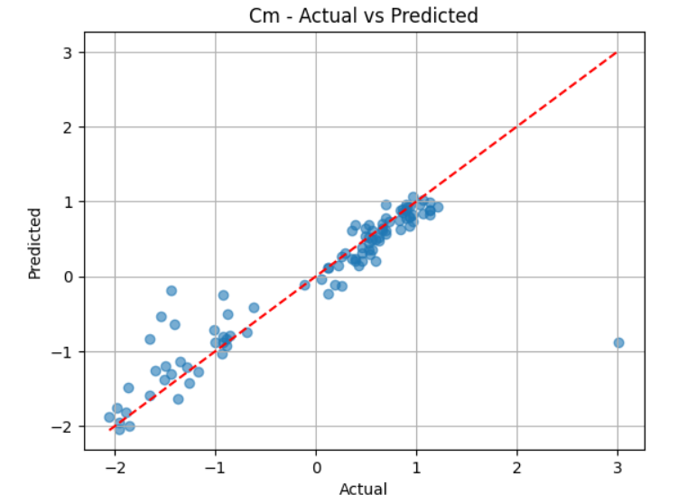

**C.** Deep Neural Network (DNN)

A Deep Neural Network (DNN) is an extension of the traditional ANN, with many more layers of neurons (hence the term "deep"). DNNs are capable of learning highly complex patterns in data. In the context of CFD and aerodynamic optimization, DNNs are used to predict aerodynamic characteristics based on various input features, such as angle of attack, airfoil shape, or flow conditions [9] [2].

* Structure: Multiple hidden layers → Output layer

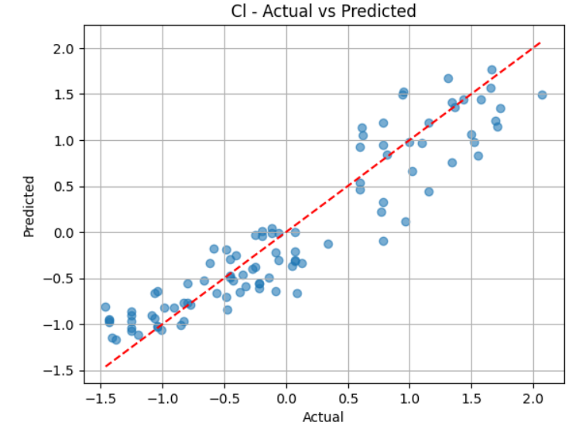 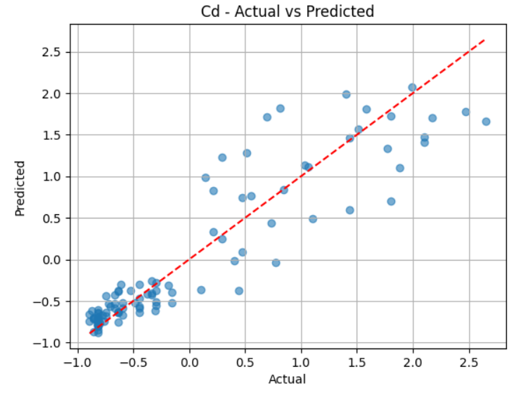 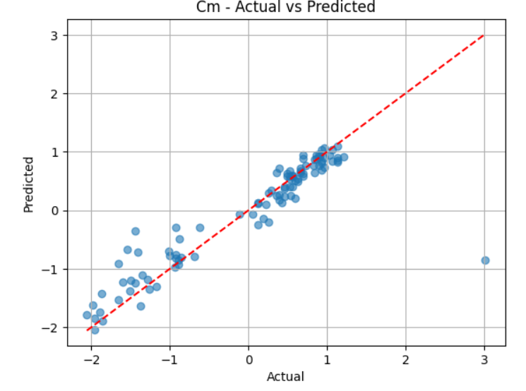

**F.** Artificial Neural Network (ANN) + Genetic Algorithm (GA)

This approach combines ANN for predicting aerodynamic coefficients and GA for optimizing airfoil geometry. The ANN learns the relationship between airfoil parameters and outputs like Cl and Cd, while the GA searches for the best-performing designs. Together, they enable efficient aerodynamic optimization without repeated CFD simulations [13].

* Structure: ANN → GA Evaluation → Selection → Crossover/Mutation → New Designs → Loop

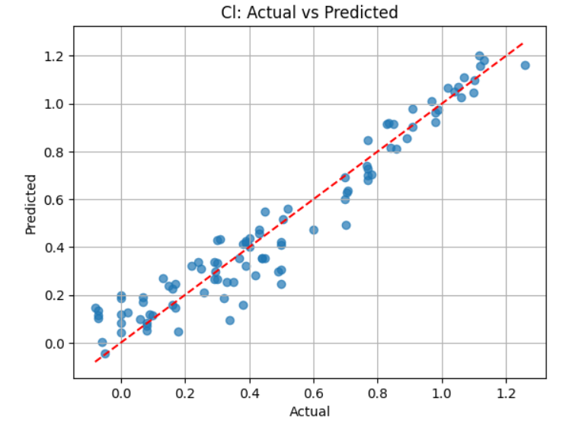 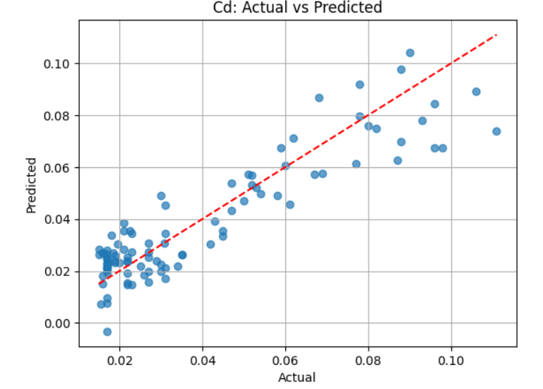 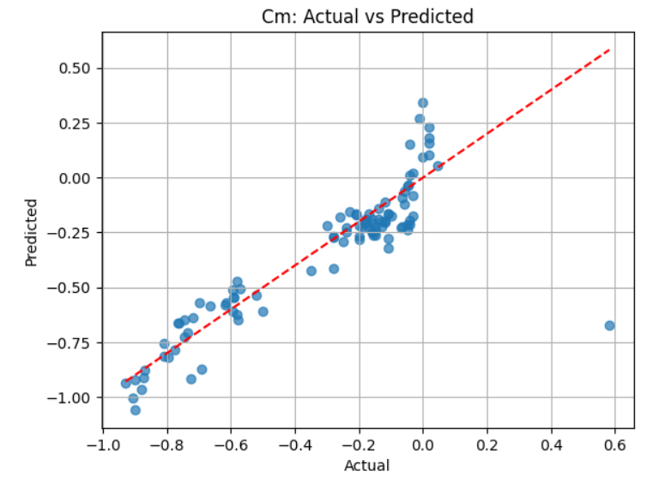

**G.** Physics-Informed Neural Network (PINN)

A PINN uses both data and physical laws, like the Navier-Stokes equations, during training. It ensures the outputs (e.g., pressure, velocity) obey fluid dynamics. PINNs are especially useful where data is limited but physics is well known[20].

* Structure: Input → Neural Network → Output → Physics Loss + Data Loss → Feedback Loop

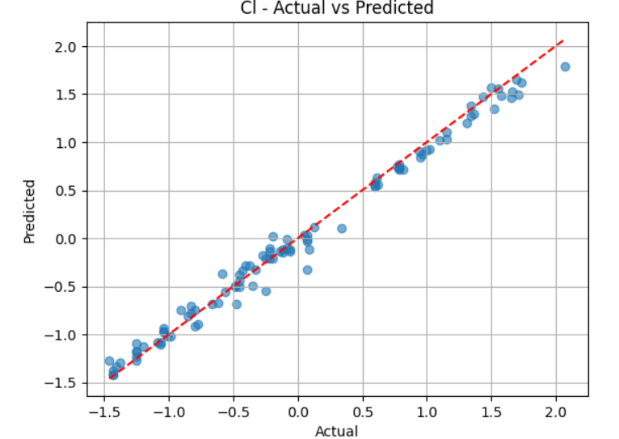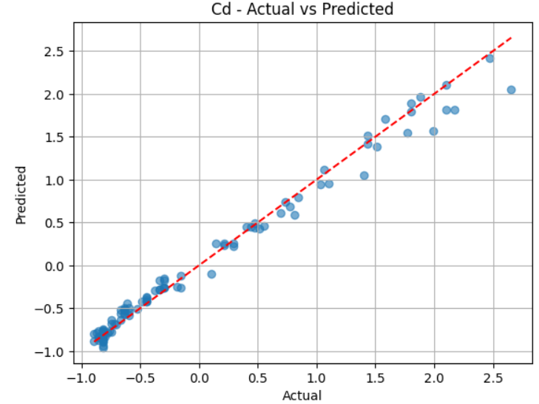 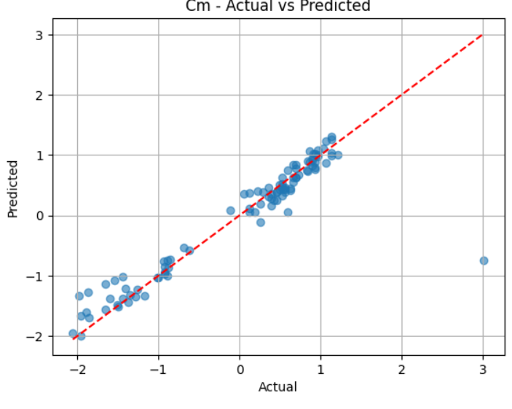

**H.** Support Vector Regression (SVR)  
SVR is a regression algorithm that fits the best line (or curve) within a threshold margin to predict continuous aerodynamic outputs like Cl and Cd. It is effective for small-to-medium datasets and captures nonlinear relationships by using kernel functions.

* Structure: Input Parameters → Kernel Transformation → SVR Model → Predicted Output

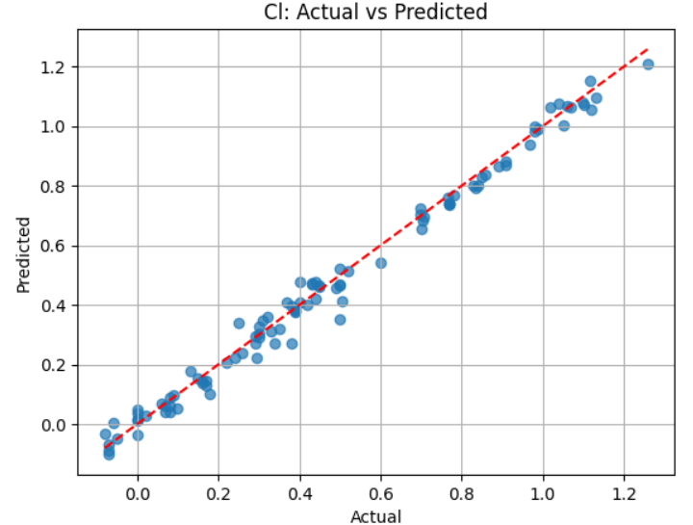 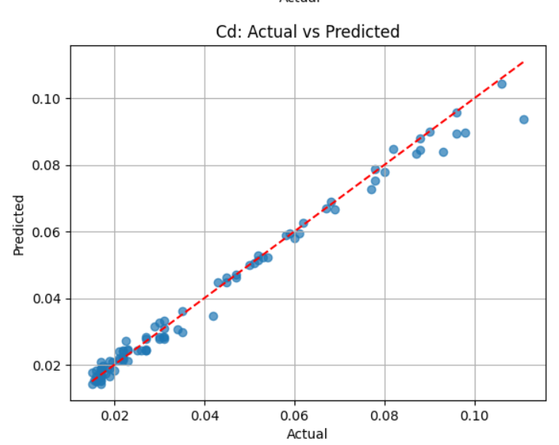 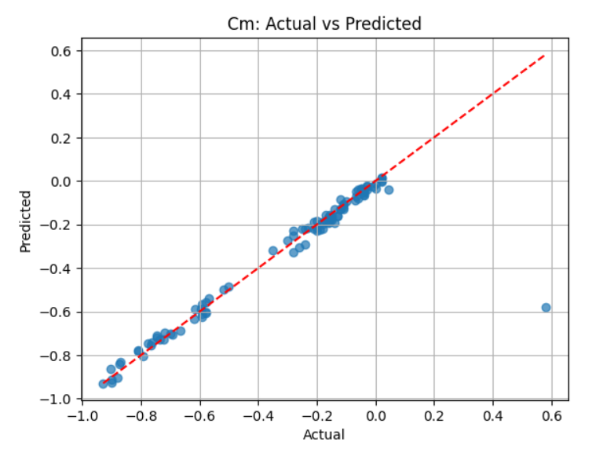

**I.** Random Forest (RF)

Random Forest is an ensemble learning method that uses multiple decision trees to predict aerodynamic coefficients. It reduces overfitting and increases accuracy by averaging results from various trees trained on different subsets of data.​

* Structure: Input Parameters → Multiple Decision Trees → Voting/Averaging → Final Prediction

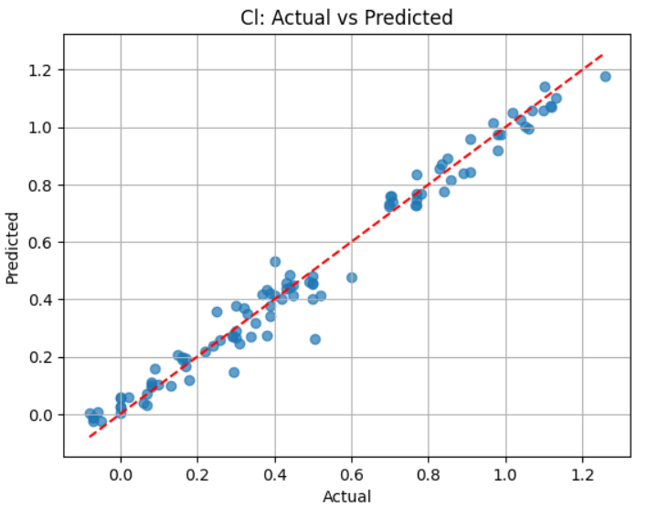 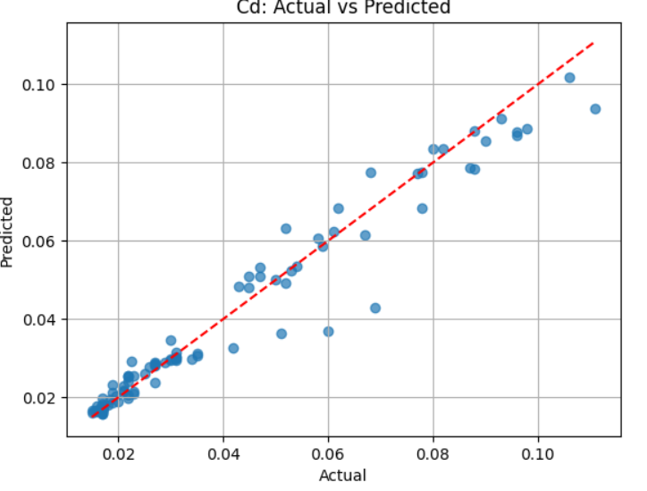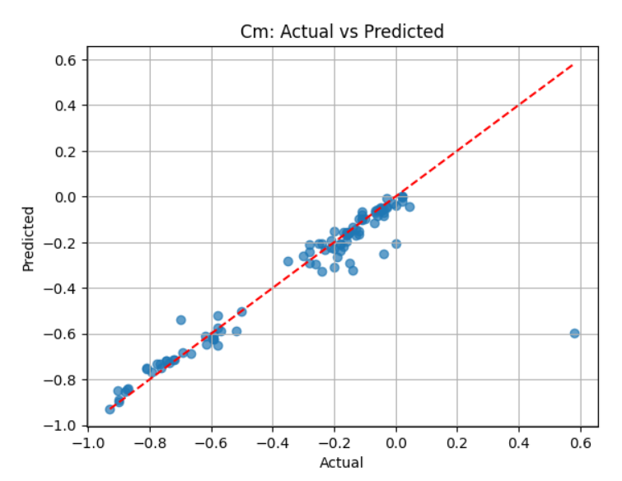

**L.** Multi-Layer Perceptron (MLP)

MLP is a type of feedforward artificial neural network consisting of input, hidden, and output layers. It is commonly used for regression and classification tasks in aerodynamics, such as predicting Cl, Cd, and Cm from airfoil shape parameters. MLP learns complex nonlinear mappings between input and output through backpropagation.​

* Structure: Input Layer → Hidden Layers (with Activation Functions) → Output Layer (Predicted Coefficients)​

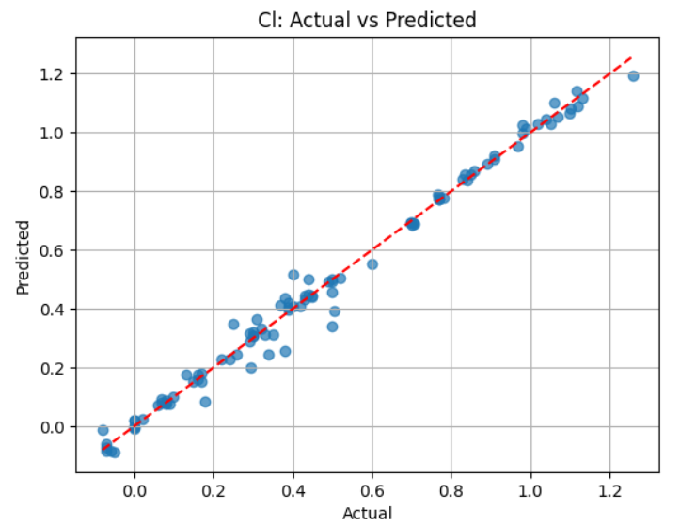 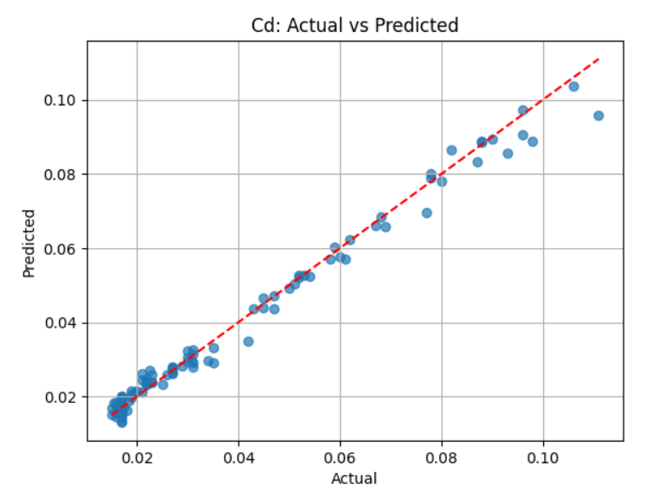 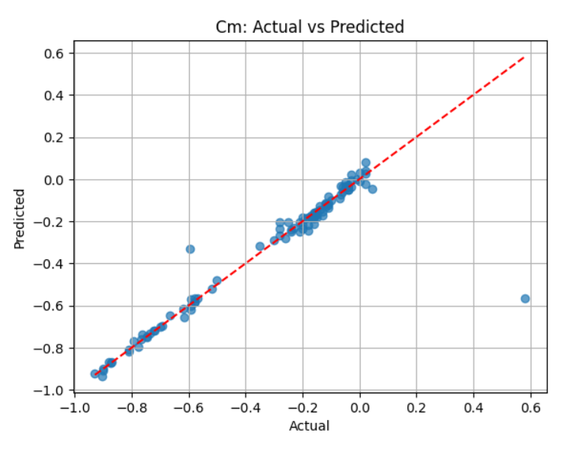

**3.RESULT & DISCUSSION**

To assess the predictive performance of the machine learning model developed for estimating aerodynamic coefficients (Cl, Cd, and Cm), four standard regression evaluation metrics were employed: Mean Squared Error (MSE), Root Mean Squared Error (RMSE), Mean Absolute Error (MAE), and the Coefficient of Determination (R²). These metrics provide a comprehensive evaluation of the model’s accuracy, reliability, and generalization ability within aerodynamic prediction tasks.

* Mean Squared Error (MSE) represents the average of the squared differences between predicted and actual values. It heavily penalizes large errors, making it a sensitive measure for identifying deviations in model performance. Its use is well-documented in [1], [2], [10]and [13] where it served as a key benchmark for prediction accuracy.
* Root Mean Squared Error (RMSE) is derived from MSE and retains the same unit as the target variable, allowing for direct interpretability in the context of aerodynamic coefficients. RMSE is widely adopted in works including [1], [2], [7], [13] where it was used to evaluate the precision of models in simulating aerodynamic behavior.
* Mean Absolute Error (MAE) calculates the average magnitude of the errors between predicted and actual values, without emphasizing outliers. Its robustness makes it a dependable metric for assessing consistent predictive accuracy, as demonstrated in prior studies such as [2], [7], [10]
* Coefficient of Determination (R²) quantifies the proportion of variance in the target variables that is explained by the model. A value close to 1 (0) to 100% indicates excellent predictive capability. This metric has been extensively used in [1], [7], [13] to highlight the model’s effectiveness in capturing the underlying relationships in aerodynamic data.

Overall, the combined use of these four metrics ensures a thorough evaluation of the model's ability to predict aerodynamic performance, aligning with best practices reported across the referenced literature.

Comparison table

|  |  |  |  |  |  |  |
| --- | --- | --- | --- | --- | --- | --- |
| Model | parameter | Predicted Values | MSE | MAE | R^2 | RMSE |
| PINN | CL | 0.6690 | 0.0117 | 0.0814 | 98.72 | 0.1083 |
|  | CD | 0.2599 | 0.0154 | 0.0834 | 98.34 | 0.1239 |
|  | CM | -0.1208 | 0.1766 | 0.1737 | 83.84 | 0.4203 |
| ANN | CL | -1.2060 | 0.0114 | 0.0753 | 98.75 | 0.1068 |
|  | CD | -1.2219 | 0.0116 | 0.697 | 98.75 | 0.1077 |
|  | CM | -1.1378 | 0.1575 | 0.1271 | 85.44 | 0.3968 |
| MLP | CL | 0.9196 | 0.0015 | 0.0247 | 98.82 | 0.0393 |
|  | CD | 0.0731 | 0.0000 | 0.0021 | 98.64 | 0.0030 |
|  | CM | -0.6071 | 0.0146 | 0.0314 | 84.82 | 0.1208 |
| DNN | CL | 0.1263 | 0.1226 | 0.2824 | 86.58 | 0.3502 |
|  | CD | -0.1308 | 0.1438 | 0.2551 | 84.47 | 0.3792 |
|  | CM | -0.2345 | 0.2195 | 0.2215 | 79.71 | 0.4685 |
| CNN | CL | 0.9472 | 0.0018 | 0.0300 | 98.60 | 0.0429 |
|  | CD | 0.0729 | 0.0000 | 0.0020 | 99.03 | 0.0026 |
|  | CM | -0.5886 | 0.0149 | 0.0444 | 84.44 | 0.1223 |
| SVR | CL | 0.9644 | 0.0015 | 0.0304 | 98.84 | 0.0389 |
|  | CD | 0.0749 | 0.0000 | 0.0019 | 98.69 | 0.0030 |
|  | CM | -0.6331 | 0.0142 | 0.0323 | 85.12 | 0.1193 |
| RANDOM  FOREST | CL | 0.9968 | 0.0031 | 0.0432 | 97.60 | 0.0561 |
|  | CD | 0.0400 | 0.0001 | 0.0057 | 92.32 | 0.0072 |
|  | CM | -0.6688 | 0.0235 | 0.0863 | 75.50 | 0.1532 |
| ANN+GA | CL | 0.9116 | 0.0096 | 0.0766 | 92.71 | 0.0977 |
|  | CD | 0.0677 | 0.0001 | 0.0089 | 82.05 | 0.0110 |
|  | CM | -0.7648 | 0.0260 | 0.0900 | 72.96 | 0.1622 |

For Cl (Lift Coefficient) prediction, MLP achieved an MSE of 0.9196, MAE of 0.0015, RMSE of 0.0393, and a high R² of 98.82%, indicating excellent fit and low variance from experimental data. For Cm (Moment Coefficient), MLP led with an MSE of -0.6071, MAE of 0.0146, RMSE of 0.1208, and an R² of 84.82%. In the case of Cd (Drag Coefficient), although CNN slightly outperformed with an R² of 99.03%, MLP showed highly competitive performance with an MSE of 0.0731, MAE of 0.0000, RMSE of 0.0030, and an R² of 98.64%.

Based on the evaluation metrics from the comparison table, MLP shows the best overall performance for Cl and Cm, with lowest errors and high R² values.CNN is the most accurate model for Cd, achieving the highest R² (99.03%) and near-zero error.While models like SVR and PINN are consistent, ANN+GA, ANN, and DNN underperform in predicting Cm.

MLP

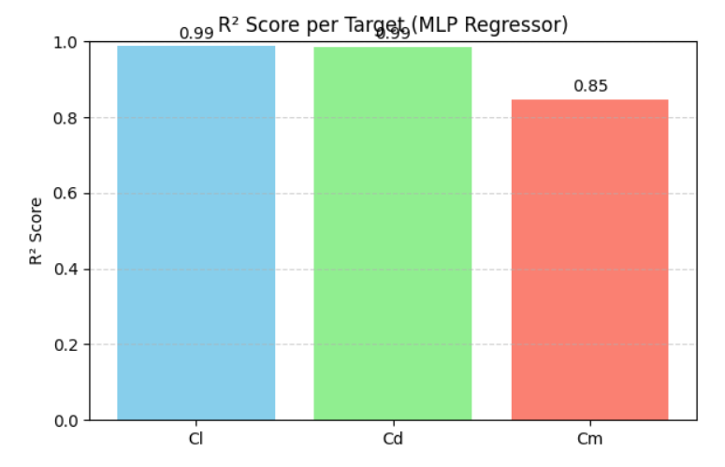 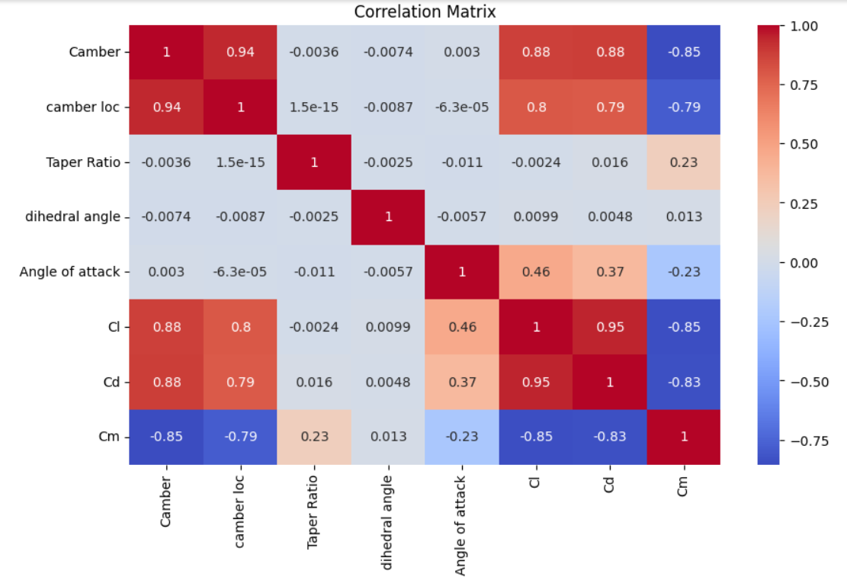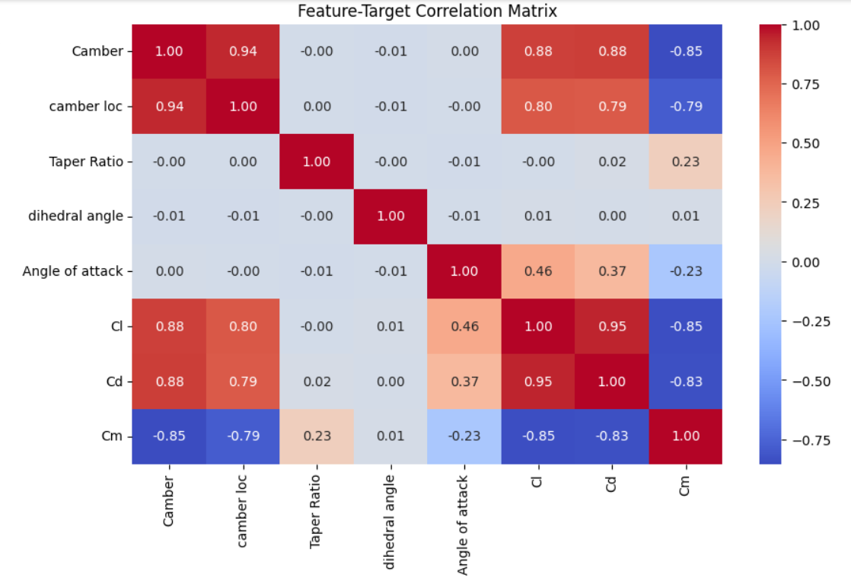

CNN

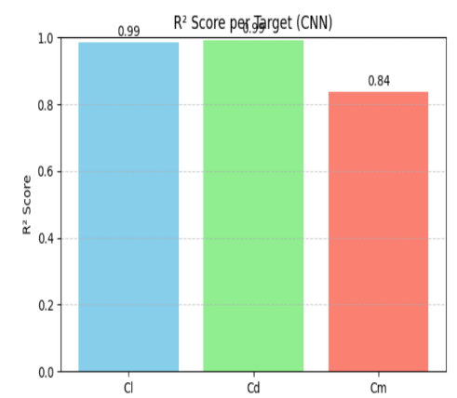 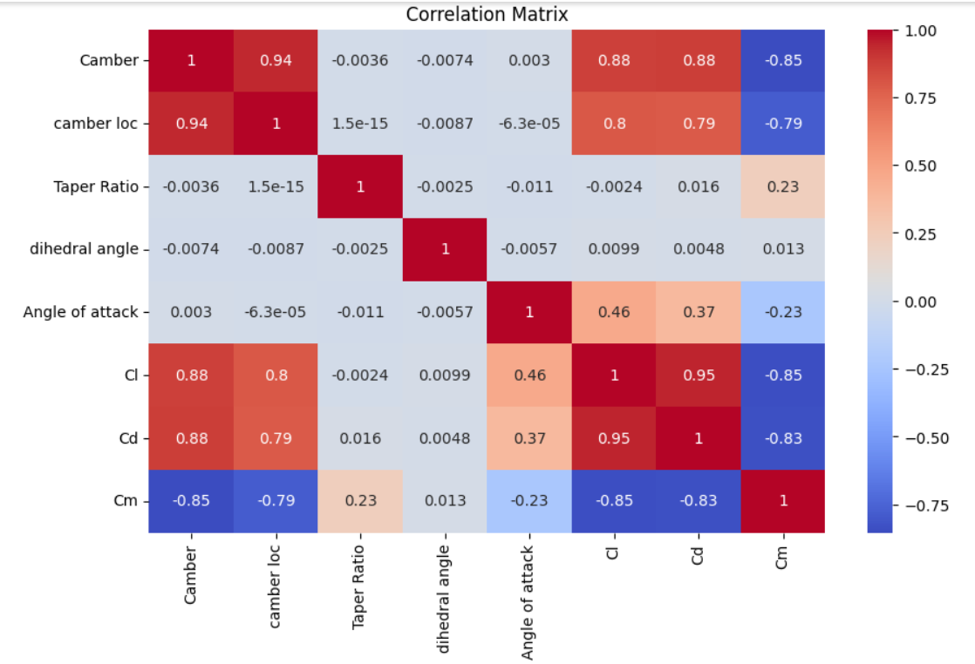 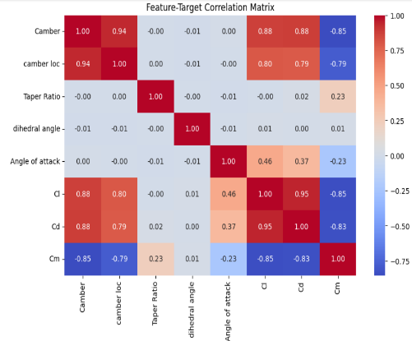

**4.CONCLUSION**

This study explored how machine learning (ML) models can be used to predict important aerodynamic properties of airfoils—specifically the lift coefficient (Cl), drag coefficient (Cd), and moment coefficient (Cm). Instead of running time-consuming CFD simulations for each new design, we trained various ML models on data generated using OpenVSP and VSPAero. The goal was to find which model could give accurate results while saving time and computational resources.

We tested several models including MLP, CNN, ANN, DNN, SVR, Random Forest, and Physics-Informed Neural Networks (PINNs). After evaluating them using standard error metrics like MSE, MAE, RMSE, and R², we found that the Multi-Layer Perceptron (MLP) performed the best overall for Cl and Cm, while the Convolutional Neural Network (CNN) was the most accurate for Cd. These models showed high R² values (above 98%) and low error rates, proving that they can reliably predict aerodynamic behaviour.

Other models like ANN+GA and SVR also showed decent results, but they were not as consistent across all parameters. Some models, especially DNN and traditional ANN, struggled more with predicting the moment coefficient (Cm). This highlights the importance of choosing the right model based on the specific aerodynamic parameter being predicted.

ML models—especially MLP and CNN—can serve as effective and efficient tools for predicting aerodynamic performance. They can greatly reduce the need for repeated CFD simulations, making the design and testing of airfoils faster and more practical, especially for students, researchers, and engineers working on early-stage aircraft or wing designs.

Overall, the MLP model not only demonstrated superior predictive performance but also provided balanced accuracy across all aerodynamic outputs. Its capability to deliver low error margins and high correlation with reference data makes it a reliable and practical tool for aerodynamic coefficient prediction. Thus, it is recommended as the optimal machine learning model for similar regression-based aerodynamic studies and can serve as a foundation for more advanced hybrid modelling approaches in the future.

**References**

[1] A. Teimourian, D. Rohacs, K. Dimililer, H. Teimourian, M. Yildiz, and U. Kale, “Airfoil aerodynamic performance prediction using machine learning and surrogate modeling,” *Heliyon*, vol. 10, no. 8, p. e29377, Apr. 2024, doi: 10.1016/j.heliyon.2024.e29377.

[2] K. Zuo, Z. Ye, S. Bu, X. Yuan, and W. Zhang, “Fast simulation of airfoil flow field via deep neural network,” Dec. 07, 2023, *arXiv*: arXiv:2312.04289. doi: 10.48550/arXiv.2312.04289.

[3] X. Song, L. Wang, and X. Luo, “Airfoil optimization using a machine learning-based optimization algorithm,” *J. Phys. Conf. Ser.*, vol. 2217, no. 1, p. 012009, Apr. 2022, doi: 10.1088/1742-6596/2217/1/012009.

[4] S. H. Khan *et al.*, “Aerodynamic analysis and ANN-based optimization of NACA airfoils for enhanced UAV performance,” *Sci. Rep.*, vol. 15, no. 1, p. 11998, Apr. 2025, doi: 10.1038/s41598-025-95848-4.

[5] S. Sahibzada, F. S. Malik, S. Nasir, and S. K. Lodhi, “Generative AI Driven Aerodynamic Shape Optimization: A Neural Network-Based Framework for Enhancing Performance and Efficiency,” *Int. J. Innov. Res. Comput. Sci. Technol.*, vol. 13, no. 1, pp. 98–105, Jan. 2025, doi: 10.55524/ijircst.2025.13.1.15.

[6] H. Chen, L. He, W. Qian, and S. Wang, “Multiple Aerodynamic Coefficient Prediction of Airfoils Using a Convolutional Neural Network,” *Symmetry*, vol. 12, no. 4, p. 544, Apr. 2020, doi: 10.3390/sym12040544.

[7] A. Anand, M. M. Safdar, K. Marepally, and J. D. Baeder, “A Comprehensive Review of Neural Network Training Approaches for Airfoil Design and Optimization,” in *AIAA SCITECH 2025 Forum*, Orlando, FL: American Institute of Aeronautics and Astronautics, Jan. 2025. doi: 10.2514/6.2025-0271.

[8] Y. Zhang, W. J. Sung, and D. N. Mavris, “Application of Convolutional Neural Network to Predict Airfoil Lift Coefficient,” in *2018 AIAA/ASCE/AHS/ASC Structures, Structural Dynamics, and Materials Conference*, Kissimmee, Florida: American Institute of Aeronautics and Astronautics, Jan. 2018. doi: 10.2514/6.2018-1903.

[9] M.-F. Negoita and M.-V. Hothazie, “A Machine Learning-Based Approach for Predicting Aerodynamic Coefficients Using Deep Neural Networks and CFD Data,” *INCAS Bull.*, vol. 16, no. 4, pp. 91–104, Dec. 2024, doi: 10.13111/2066-8201.2024.16.4.9.

[10] H. Moin, H. Z. I. Khan, S. Mobeen, and J. Riaz, “Airfoil’s Aerodynamic Coefficients Prediction using Artificial Neural Network,” in *2022 19th International Bhurban Conference on Applied Sciences and Technology (IBCAST)*, Aug. 2022, pp. 175–182. doi: 10.1109/IBCAST54850.2022.9990112.

[11] E. Saetta, R. Tognaccini, and G. Iaccarino, “Machine Learning to Predict Aerodynamic Stall,” *Int. J. Comput. Fluid Dyn.*, vol. 36, no. 7, pp. 641–654, Aug. 2022, doi: 10.1080/10618562.2023.2171021.

[12] H. Xiang, Y. Ma, Z. Dai, C. Wang, and B. Zhang, “AeroDiT: Diffusion Transformers for Reynolds-Averaged Navier-Stokes Simulations of Airfoil Flows,” Dec. 23, 2024, *arXiv*: arXiv:2412.17394. doi: 10.48550/arXiv.2412.17394.

[13] M.-F. Negoita, D.-E. Crunteanu, M.-V. Hothazie, and M.-V. Pricop, “Enhancing Airfoil Performance through Artificial Neural Networks and Genetic Algorithm Optimization,” *INCAS Bull.*, vol. 15, no. 4, pp. 199–209, Dec. 2023, doi: 10.13111/2066-8201.2023.15.4.17.

[14] C. Unlusoy *et al.*, “Advancing Airfoil Design: A Physics-Inspired Neural Network Model,” in *Volume 12D: Turbomachinery — Multidisciplinary Design Approaches, Optimization, and Uncertainty Quantification; Radial Turbomachinery Aerodynamics; Unsteady Flows in Turbomachinery*, London, United Kingdom: American Society of Mechanical Engineers, Jun. 2024, p. V12DT34A010. doi: 10.1115/GT2024-122682.

[15] A. Sridharan, “A Comparative Evaluation of Select Shape Parameterization Approaches for Airfoil Optimization Using Neural Networks,” in *AIAA AVIATION FORUM AND ASCEND 2024*, Las Vegas, Nevada: American Institute of Aeronautics and Astronautics, Jul. 2024. doi: 10.2514/6.2024-4664.

[16] J. D. Anderson, *Introduction to flight*, 5th ed. in McGraw-Hill series in aeronautical and aerospace engineering. Boston: McGraw-Hill Higher Education, 2005.

[17] B. Wang and J. Wang, “Application of Artificial Intelligence in Computational Fluid Dynamics,” *Ind. Eng. Chem. Res.*, vol. 60, no. 7, pp. 2772–2790, Feb. 2021, doi: 10.1021/acs.iecr.0c05045.

[18] S. S. Haykin and S. S. Haykin, *Neural networks and learning machines*, 3rd ed. New York: Prentice Hall, 2009.

[19] K. P. Murphy, *Machine Learning - A Probabilistic Perspective*. in Adaptive Computation and Machine Learning. Cambridge: MIT Press, 2014.

[20] M. Raissi, P. Perdikaris, and G. E. Karniadakis, “Physics-informed neural networks: A deep learning framework for solving forward and inverse problems involving nonlinear partial differential equations,” *J. Comput. Phys.*, vol. 378, pp. 686–707, Feb. 2019, doi: 10.1016/j.jcp.2018.10.045.

[21] X. Guo, W. Li, and F. Iorio, “Convolutional Neural Networks for Steady Flow Approximation,” in *Proceedings of the 22nd ACM SIGKDD International Conference on Knowledge Discovery and Data Mining*, San Francisco California USA: ACM, Aug. 2016, pp. 481–490. doi: 10.1145/2939672.2939738.